AI LAB EXP – 5

**BFS AND A* ALGORITHM FOR REAL WORLD PROBLEMS**

**Tejas Ashok**

**RA1911030010090**

**AIM**

To implement Best First Algorithm and A* Algorithm using python.

**BEST FIRST SEARCH**

**ALGORITHM**

* Define a list, OPEN, consisting solely of a single node, the start node, s.
* IF the list is empty, return failure.
* Remove from the list the node n with the best score (the node where f is the minimum), and move it to a list, CLOSED.
* Expand node n.
* IF any successor to n is the goal node, return success and the solution (by tracing the path from the goal node to s).
* FOR each successor node:
  1. Apply the evaluation function, f, to the node.
  2. IF the node has not been in either list, add it to OPEN.
* Looping structure by sending the algorithm back to the second step.

**CODE**

from queue import PriorityQueue

v = 14

graph = [[] for i in range(v)]

def best_first_search(source, target, n):

visited = [0] * n

visited[0] = True

pq = PriorityQueue()

pq.put((0, source))

while pq.empty() == False:

u = pq.get()[1]

print(u, end=" ")

if u == target:

break

for v, c in graph[u]:

if visited[v] == False:

visited[v] = True

pq.put((c, v))

print()

def addedge(x, y, cost):

graph[x].append((y, cost))

graph[y].append((x, cost))

addedge(0, 1, 3)

addedge(0, 2, 6)

addedge(0, 3, 5)

addedge(1, 4, 9)

addedge(1, 5, 8)

addedge(2, 6, 12)

addedge(2, 7, 14)

addedge(3, 8, 7)

addedge(8, 9, 5)

addedge(8, 10, 6)

addedge(9, 11, 1)

addedge(9, 12, 10)

addedge(9, 13, 2)

source = 0

target = 9

best_first_search(source, target, v)

**OUTPUT**

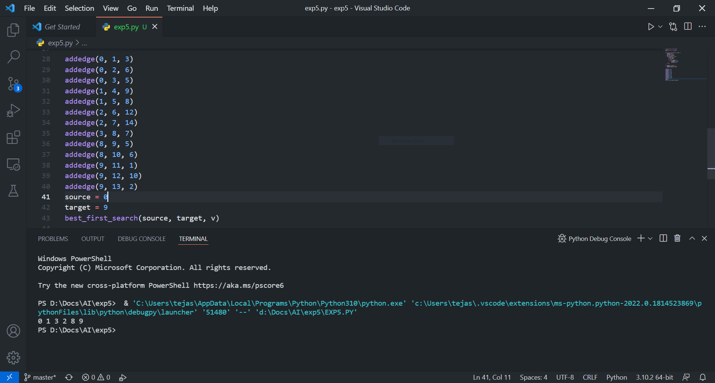

**A* SEARCH ALGORITHM**

**ALGORITHM**

* We create two lists – Open List and Closed List (just like Dijkstra Algorithm)
* Initialize the open list
* Initialize the closed list put the starting node on the open list (you can leave its f at zero)
* While the open list is not empty
  1. Find the node with the least f on the open list, call it "q"
  2. Pop q off the open list
  3. Generate q's 8 successors and set their parents to q
  4. For each successor
     1. If successor is the goal, stop search
     2. Else, compute both g and h for successor
* successor.g = q.g + distance between successor and q
* successor.h = distance from goal to successor(This can be done using many ways, we will discuss three heuristics- Manhattan, Diagonal and Euclidean Heuristics)
* successor.f = successor.g + successor.h
  + 1. If a node with the same position as successor is in the OPEN list which has a lower f than successor, skip this successor
    2. If a node with the same position as successor is in the CLOSED list which has a lower f than successor, skip this successor otherwise, add the node to the open list

end (for loop)

* + 1. Push q on the closed list

end (while loop)

**CODE**

def aStarAlgo(start_node, stop_node):

open_set = set(start_node)

closed_set = set()

g = {}

parents = {}

g[start_node] = 0

parents[start_node] = start_node

while len(open_set) > 0:

n = None

for v in open_set:

if n == None or g[v] + heuristic(v) < g[n] + heuristic(n):

n = v

if n == stop_node or Graph_nodes[n] == None:

pass

else:

for (m, weight) in get_neighbors(n):

if m not in open_set and m not in closed_set:

open_set.add(m)

parents[m] = n

g[m] = g[n] + weight

else:

if g[m] > g[n] + weight:

g[m] = g[n] + weight

parents[m] = n

if m in closed_set:

closed_set.remove(m)

open_set.add(m)

if n == None:

print('Path does not exist!')

return None

if n == stop_node:

path = []

while parents[n] != n:

path.append(n)

n = parents[n]

path.append(start_node)

path.reverse()

print('Path found: {}'.format(path))

return path

open_set.remove(n)

closed_set.add(n)

print('Path does not exist!')

return None

def get_neighbors(v):

if v in Graph_nodes:

return Graph_nodes[v]

else:

return None

def heuristic(n):

H_dist = {

'A': 11,

'B': 6,

'C': 99,

'D': 1,

'E': 7,

'G': 0,

}

return H_dist[n]

Graph_nodes = {

'A': [('B', 2), ('E', 3)],

'B': [('C', 1), ('G', 9)],

'C': None,

'E': [('D', 6)],

'D': [('G', 1)],

}

aStarAlgo('A', 'G')

**OUTPUT**

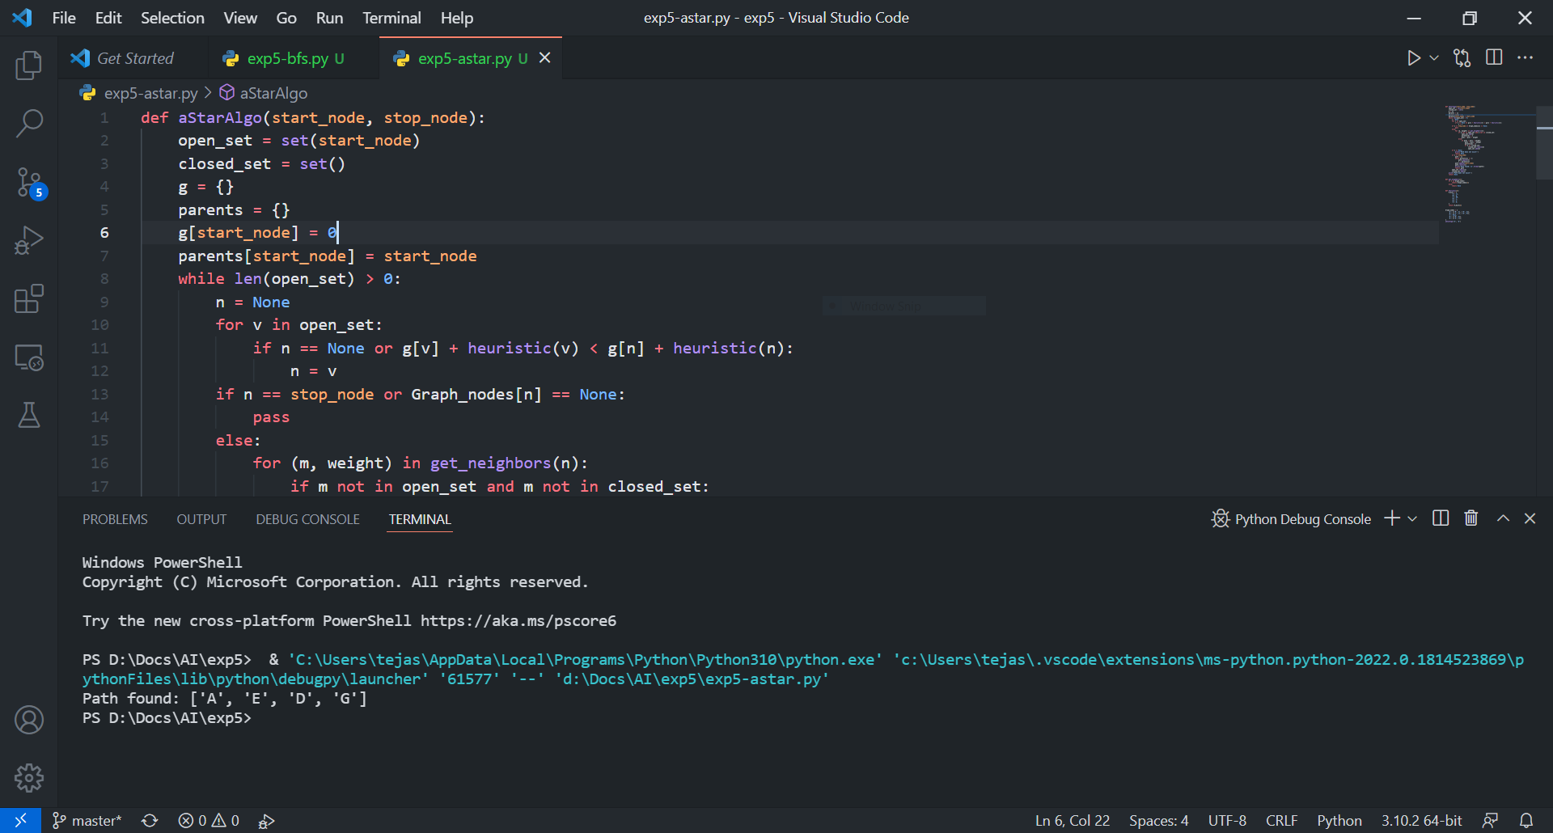

**RESULT**

Best first search and A* search algorithm were successfully executed in python.